Day- 34 - Terraform Workspace

- If we want to create multiple environments, we can make use of terraform workspaces. Terraform will give us special variable called terraform.workspace
Terraform.workspace=dev
Terraform.workspace=uat
Terraform.workspace=prod

- We can use the below commands for utilizing terraform workspace
- Terraform workspace –help
- Terraform workspace list
Terraform init is important for using terraform workspace in terminal

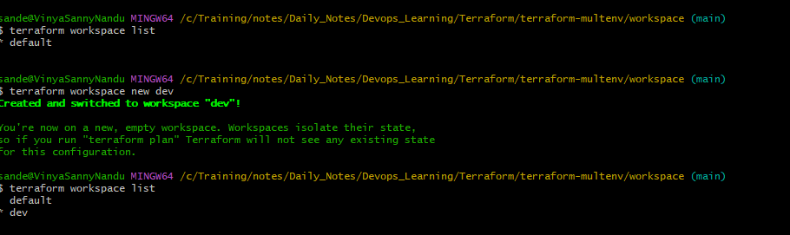

Tfvars

Terraform init -backend-config=dev/backend.tf
Terraform init -reconfigure -backend-config=prod/backend.tf

Terraform

